DATABASE CONNECTION
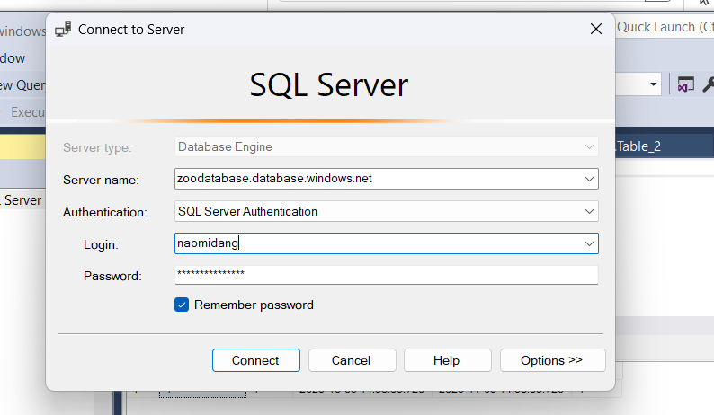
Server name: zoodatabase.database.windows.net
Login: naomidang
Password: Tryyourbest123

